**Purpose:** This integration helps to create Subscription in Subscription from Oracle CPQ.

1. **Step – 1**

Click on the “New Transaction” on in Transaction Manager Page.

1. **Step – 2**

A new transaction will be created.

Select the Business Unit Name, then the respected Legal Entity Name will be auto populated.

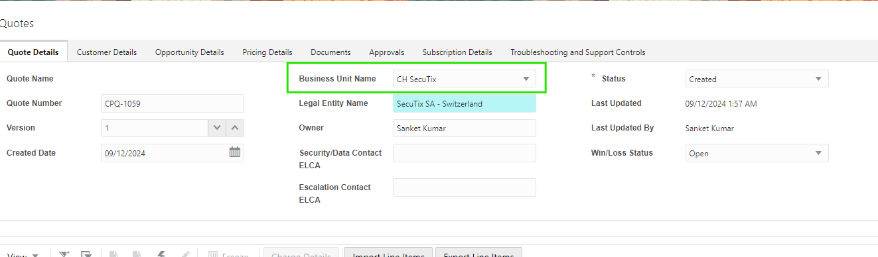

1. **Step -3**

Add the Item using the Quick add button.

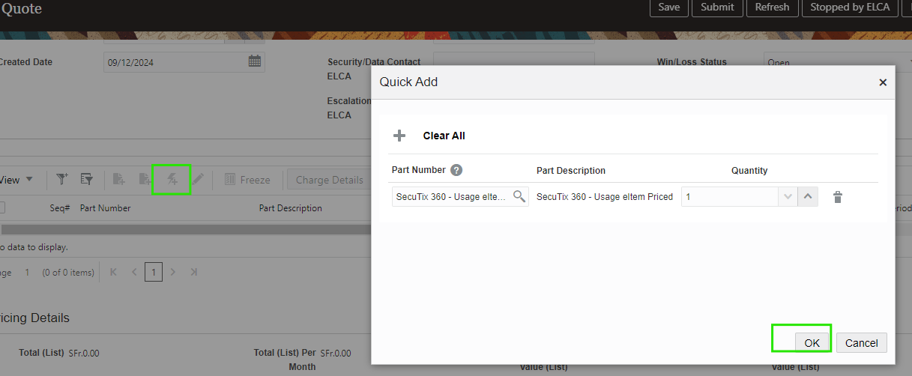

1. **Step – 4**

Put the Contract start date and contract end date at line.

1. **Step – 5**

Put the Default Request Date and End Date in the subscription Details tab.

1. **Step 6**

Open the Line and enter the Subscription details.

1. **Step – 7**

Click the Browse button in “Customer Details” tab, Search with the “customer Id” and populate.

1. **Step -8**

Submit the quote for approval. Then the approval process will begin.

1. **Step 9**

After approval click on the “Quote submitted to Customer” and click on “Approve By Customer”.

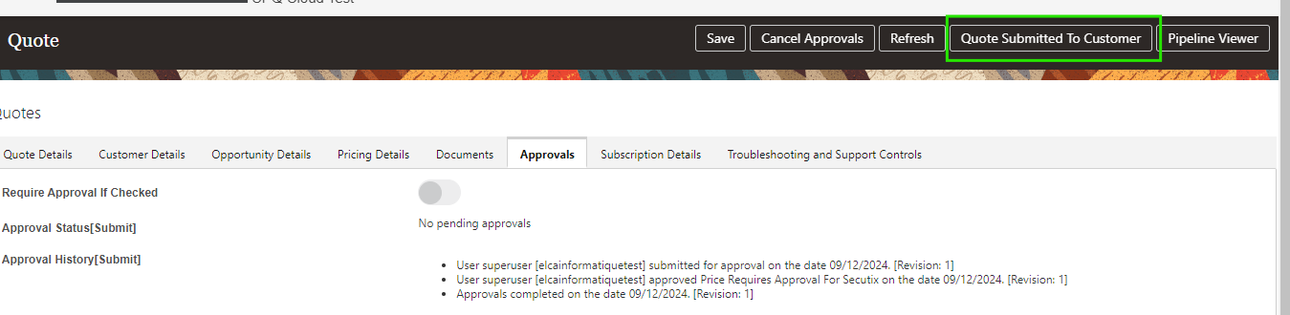

1. **Step 10**

After Customer approval process finished, then upload the Quote Signed document in Document tab and click on “Quote Signed”

